Scenario 1: Casual gamers assist in mapping jungle areas wrt specific vegetation, insects, animals etc.,

Located just 30km north of the tony South Mumbai neighbourhood, the city’s 104 sq km green lung is the only protected urban forest in the whole of India.

Though not strictly contributing toward Observations from Satellite, several crowdsourcing initiatives collect VGI that can help significantly increase and catalogue local knowledge and observations. eBird [9] is one of the excellent long standing examples that harness the power of crowdsourced ornithological observations across the world and conduct scientific studies at large scale, which would not have been possible with traditional means of scientific study. The large amounts of data (250 million observations covering 98.5% of world’s bird species, provided by 300 thousand users (As presented by Rick Bonney in his keynote at ECSA conference, May 2016; notes from [48])) collected from eBird is open access and has also been instrumental in several scientific publications, demonstrating the value of such crowdsourced data. Similar initiatives in recording observations in nature also exist in other domains such as Leafsnap [49] (automatically identifying and recording plant species from physical attributes such as leaf shape, colour, etc.), NatureServe [50] (recording animal,
plant and habitats), and GeoExposures [51] (documenting geological features such as excavation, pipelines, surveys, etc.).

https://www.google.co.in/url?sa=t&rct=j&q=&esrc=s&source=web&cd=7&cad=rja&uact=8&ved=0ahUKEwj87JHPg53aAhXMuY8KHdIvAP4QFghoMAY&url=http%3A%2F%2Fwww.mdpi.com%2F2072-4292%2F9%2F1%2F87%2Fpdf&usg=AOvVaw1dkdKNlIN-9znoAqrgF--6

- eBird : application_address

----
- Geo-Fencing -
- Biotelemetry - the instrumental technique for gaining and transmitting information from a living organism and its environment to a remote observer.
  - Photo Identification
  - Passive integrated transponder (PIT) tags consist of an integrated circuit chip, capacitor, and antenna coil encased in glass.
  - Passive integrated transponder (PIT) tags consist of an integrated circuit chip, capacitor, and antenna coil encased in glass.

- Audio Devices to record sound. Complemented by Photo Identification.
- In a first, radio tags for Shimla trees to curb illegal felling.
- “The Songs of Trees: Stories from Nature’s Great Connectors” by David G. Haskell.
  - The biologist and writer first immersed himself in the sounds of nature when he learned to identify birds by their songs.
- Govt. and NGO’s use Tree Tags (as is there in IITB).
  - students from the Green Campus department, under the National Service Scheme (NSS) at IIT-B recorded a total of 200 trees of 40 species.
  - used a 2008 report by the World Wide Fund for Nature as reference, since that is the only available documentation of tree species on campus.
- Maharashtra Urban Areas (Protection and Preservation of Trees) Act, 1975.
  - Every individual tree gets photographed and is automatically tagged to the Global Positioning System (GPS).

Scenario 2: To enhance the shopping experience of expectant mothers

Future of malls:
The trends helping to create this change include changing demographics, such as an aging population and increased urbanization, which means more people living in smaller spaces and a greater need for public spaces in which to socialize and congregate. In this environment, malls offer a welcome watering hole, especially in cities where other public spaces are not safe. Sustainability concerns are causing some consumers to prefer mixed use developments where they can live, shop and work all within walking distance – instead of having to get into a car and drive to a crowded suburban mall. The growing middle classes in Latin America and Asia maintain a strong association between consumption and pleasure, driving the need for more engaging shopping experiences.

https://www.mckinsey.com/business-functions/marketing-and-sales/our-insights/the-future-of-the-shopping-mall

Expectant moms:
And expectant parents are a retailer’s dream. Not only are they shopping frequently and spending more than ever before (conservative estimates say that you can spend over $20,000 by your baby’s first birthday, including healthcare costs), but they are willing to spend more and can often spend irrationally.

However, when pregnant, you are actually establishing spending behaviors and brand loyalty that continue as you raise your child over the subsequent decades. The customer lifetime value of expectant parents cannot be underestimated.
https://insights.newscred.com/why-expectant-parents-need-content-marketing/

Expectant mothers lack time as do sleep deprived fathers. They seek convenience and their reference to old purchasing habits is thrown out the window along with any brand loyalty. If they stop by Target for some baby supplies and see the milk and the shampoo and the underwear, they are more likely to purchase it all from Target even if this wasn’t previously a habit. In this situation convenience outweighs habit. If the change occurs once, it’s more likely to happen again, and again until the old habit is changed and a new habit formed.
http://www.trulydeeply.com.au/2012/02/expectant-mothers-targeted-for-purchase-behavior-change/

https://retail.economictimes.indiatimes.com/news/toys-kids-and-baby/babycare/loyalty-in-mother-child-care-segment-less-defined-by-brands-and-more-by-retail-experience-destination/53929301

http://blog.mitchcommgroup.com/connecting-with-millennial-moms-shopping-and-media-habits

Target can know that you are pregnant before you do in their popular 2012 article.
http://www.nytimes.com/2012/02/19/magazine/shopping-habits.html?_r=0

http://www.dnaindia.com/speak-up/report-is-a-visit-to-the-mall-putting-you-at-risk-1482633

Scenario 3: To enhance creativity in school students through activities conducted for them in the jungle

The educator and author Ken Robinson, for example, argued in an influential TED talk in 2006 that current education practices crush student’s innate creative talents. Robinson clearly touched a nerve – this became the most watched TED talk of all time

Then again, levels of creativity are falling in formal classroom settings. Children are routinely assessed using the Torrance Tests of creative thinking – for instance, they may be asked to think up alternative uses for an object such as a book or tin can. Test scores today are lower than they were in the 1990s. This may be because standardised testing encourages children to conform rather than value the trait of thinking differently.

21st Century firms emphasising the value of creativity in their employees, it’s important that teachers are allowed to value the trait in their students too – which is something that today’s curriculums often discourage, says Puccio.

http://www.bbc.com/future/story/20140314-learn-to-be-creative

Survival is more of a mind game and to survive you need to be strong enough to take on any challenge, be it at your home, workplace, in the society, in the vast wilderness of the jungles or in the rough terrains of an unknown land. The survival courses at the Jungle Survival Academy at Bandhavgarh, gives you an opportunity to live a life free of stress in the clean and serene environs of the jungle, to fight your fears, by learning basic survival skills of foraging food, getting drinking water and making a shelter from scratch and with very little resources. These courses will help you master your survival skills to take on any challenge life throws at you, for these courses are not only training you for your survival in the wilderness but it is training you to fight your fears and to live a peaceful life. Come be a part of this adventure packed survival experience and make your own adventure tales by living a life amidst the beautiful flora and fauna of the jungles of Bandhavgah. For A Survivor In The Wild Is A Survivor For Life.

https://www.junglesurvivalacademy.com/

https://www.bushmasters.co.uk/jungle-survival/

https://thesurvivalmom.com/survival-creativity/

Empower the Future: the inside story of building creative space for suburban kampong’s children Martin Katoppo*, Universitas Pelita Harapan; Phebe Valencia, Universitas Pelita Harapan

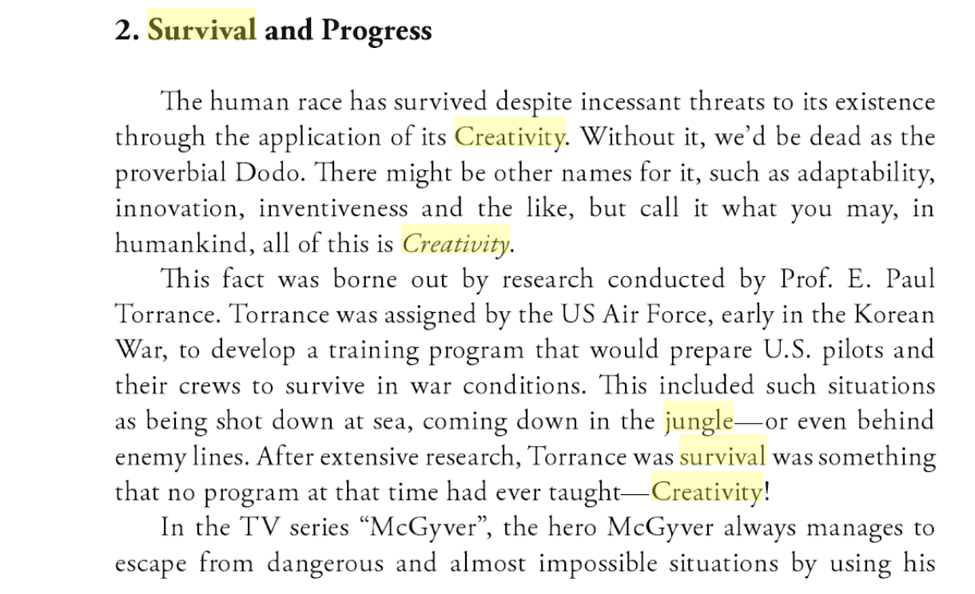

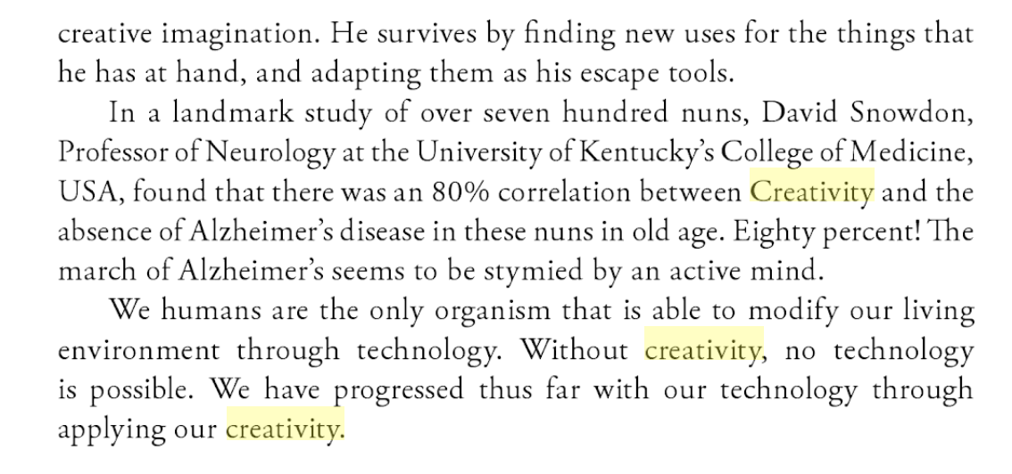

https://books.google.co.in/books?id=RGZ78cI_nJIC&pg=PA3&lpg=PA3&dq=jungle+survival+creativity&source=bl&ots=ounrbj8hom&sig=jUm4pdem4gEQ_vHdAVdBxADxOTo&hl=en&sa=X&ved=0ahUKEwiOxJaDyZzaAhVIPo8KHfRIBPwQ6AEIbzAL#v=onepage&q=jungle%20survival%20creativity&f=false

Kettle Falls is one of 160 schools in the U.S. that use the Expeditionary Learning (EL) model, which was developed by experts from Outward Bound and Harvard University. Each grade embarks on several major explorations with the goal of promoting critical thinking and creative problem solving.

creative classroom

People to speak to:
- Children
- Mountaineers, Trekkers
- Prof. AG Rao on craft & creativity
- Prof. Vivek Kant, IDC
- Prof. Rashmi Gupta, HSS
- Prof. Uday Athavankar, IDC

Questions
Can we alter the subjects to fit our context? Forest/vegetation area instead of jungle

What is the role of sensors and how should they be chosen?

Sensor- no emotions
Coveda
Making instruments specifically
Book- The songs of the trees, David George Hickle
Get lost
Ideation

RULES:

LINKS

https://www.businessinsider.in/Fourth-graders-have-ingenious-solutions-to-the-worlds-biggest-problems/articleshow/52368776.cms

https://www.fastcompany.com/3038720/kids-solve-the-most-pressing-urban-problems-with-designs-youd-never-think-up

